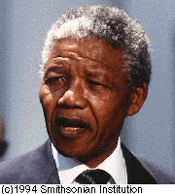
Nelson Mandela

This project contains this pages

Front Page Page 1

This project contains this pages Page 2

The story of Nelson Mandela Page 3
Member of the ANC Page 3
Arrested Page 4
The masker in Sharpeville Page 4
Arrested again Page 4
Isolated on the prison islands Page 5
The release Page 5
Threaded explosion Page 5
Threaded explosion (fort.) Page 6
References Page 6

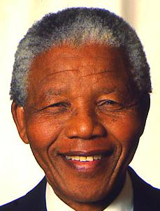

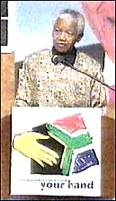
The Story of Nelson Mandela
Nelson Rolihlahia Mandela was born in 1918 in Umtala in Transkei in South Africa. His father was chief of the Tembus Tribe, which is the largest group of people in Transkei on the southeast coast of South Africa.
Nelson first studied at a high school in Fort Hare and later on he studied jurisdiction at the Witwater University in Johannesburg. He became one of the first black lawyers in the country and his office opened in one of suburbans of Johannesburg.

Member of the ANC
In 1944 only 26 years old, Nelson became a member of the organisation Africa National Congress – ANC, which already hade been created in 1912. ANC was there to improve the conditions of the black people in South Africa. They only used peaceful methods to improve the conditions. In spite of that, the authorities harassed them.

The national leader from India Mahatma Gandhi, developed the ANC of methods. Gandhi’s idea was pretty simple. By demonstrations you could force the authorities to work in your direction. He was against violence. Ghandi’s methods were successful in India but had no effect on the white people that governed South Africa. On the contrary they became more racist during the 1940’s. Especially since the National Party came into power in 1948. The authorities became angrier and pressed ANC harder.

Arrested

Nelsons lawyer buddy Oliver Tambo was together with Nelson one of the leaders in the ANC.
In 1952 Mandela was arrested for the first time and was sentenced to 9 months in prison for organising the Disobedience Campaign.
Four years later, in 1956, he was put on a new trail and was accused for betrayal. After five years of legal trials he was proved “not guilty” in a lack of evidence.

The Massacre of Sharpeville
The 21 March 1960 became the turning point in South Africa. It was the massacre of Sharpeville. The police putt in troopers, who were going to beat down the friendly demonstrators, the black people from Sharpeville. 69 people were killed and a wave of protests was heard from all over of the world.
The same year ANC became forbidden. Because of that Mandela and the other leaders started to work underground.

It became harder for the ANC leaders to talk non-violence.
A lot of young black became very inpatient and wanted to start a weapon struggle. In 1961 ANC became more violent and started to use weapons.

Arrested again
After two years of successful hiding from the police, Nelson Mandela was in 1962 caught and convicted for leaving the country without permission. For this so called crime he got five years.
Strangely, while he was in prison he was accused and convicted for high betrayer, and in 1964 he was sentenced to lifetime.
He admitted that he had had planes for armed actions.
The trail became a chance for him to talk about the racism in South Africa. Everything he said in the court was reported and written in newspapers all over the world.
Isolated on the prison islands
In 18 years he was placed on the prison island Robben Island. But 1982 he was moved to Pollsmoorprison outside Cap Town. At the beginning the only visitors aloud were his close friends and his lawyers. His last years in prison, he was allowed more visitors.
It didn’t go as the white authorities had hopped. I mean, the people did not forget Mandela, instead he became a martyr. For the blacks he became a symbol to keep on fighting.

The release
As early as 1970´s the authorities started to see that Mandela was a bigger threat in prison than outside.
The authorities suggested a trade, which involved releasing Mandela, and he had to stop with his violence. Similar suggestions were repeated many times. But every time Nelson stubbornly rejected any kind of deal.

Threatened explosion
In the summer of –88- it was known Mandela had been ill of tuberculosis in prison. Ohh noooo!
Many white people were shaken by this news, some of compassion, others of fear for their own sakes.
But what would happen if Nelson died in prison??
That was a question many people asked themselves. Now the question was at the top.
The government friendly newspaper Die Vaderland, did a column on what would happen if Mandela would die in prison. It goes like this: “If Mandela would die in prison, it would result in an internal explosion of black violence and a international commotion that would get our present situation seem comparably calm.”
When it got known that Nelson had TBC (=tuberculosis), many government friendly newspapers started to encourage to set Mandela free. They would write something like this: “The risks with his continued internment is bigger than a release.”
When F W de Klerk became president in 1989, he looked very serious into the Mandela problem and in February 1990 Nelson Rolihlahia Mandela became a free man.
And to greet him was an enormous crowd of people outside the prison ports not only blacks but whites as well.

A few weeks after the release, leaders from the ANC were gathered in Zambia, the neighbour country of South Africa.
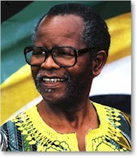
In Zambia they choose Mandela to be the vice president of the organisation. Actually it meant that he was the real president as the real president, his old friend Oliver Tambo, had suffered from a stroke. Tambo was taken care off in a Swedish hospital and it prevented him from leading the job as president over the ANC.

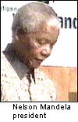
In 1993 Nelson Mandela received the Nobel Prize in Peace. And became president 1994.

Now, this was my story of Nelson Mandela I hope that you enjoyed it.

References
To be completely honest I’ve taken all my information from a paper that I got from my teacher.
The pictures come from the Internet but I don’t think it’s important to have the addresses to the sites.

Simon Gromer 23 november 00
Brandbergsskolan 9F

